School Counseling Program Newsletter
Shandrai Silva, School Counselor | March 2018

Counselor Message  March marks the beginning of spring - a time of rejuvenation and rebirth. What a wonderful time of year to re-evaluate goals, monitor progress,  and make any necessary adjustments. As school counselor at Hawks Nest, I am committed to re-evaluating the school counseling program to ensure the program is meeting the socio-emotional, cognitive and career development needs of all students.  As we “spring” into a new season, the school counseling program will continue with classroom guidance lessons, small group counseling and individual meetings with students. This month, we will begin learning more about College & Careers in classroom guidance classes. We’re also participating in another school-wide service project in March.  Looking forward to another great  month at the Nest!  ___________________________  How to see the school counselor  Classroom guidance classes are weekly based on grade level specials schedule. Small group counseling and individual counseling by self -referral, parent referral, teacher referral, administrator referral or counselor initiated.  Contact School Counselor at 704-866-8467or sosilva@gaston.k12.nc.us. | Home of the Hawks    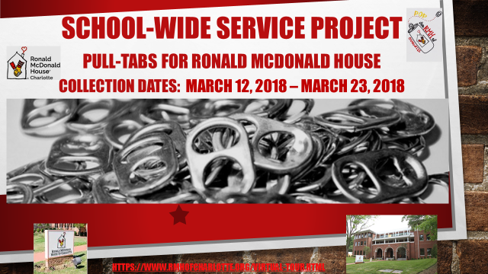  We supporitng the Rondald McDonald of  Charlotte in their effort to be “a home  away from home” for families. Collection  dates: March 12 – March 23, 2018.  Women History Month  March 2018  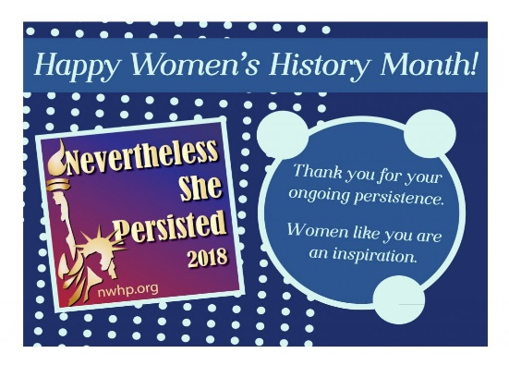 | Character Education  “We’re Soaring with Good Character”  ______________________________  The character trait of the month is Good Judgment. Good Judgment means to choose worthy goals; thinking through the consequences of your actions; and basing your decisions on wisdom and good sense.  “Intelligence plus character- that is  the goal of true education.”  Dr. Martin L. King, Jr.    _____________________________________________  Career Day is Friday, April 27th  